


Report About My website
Code, Links, meta-tags check

Names:
Ibrahim Qahtan Adnan
Group: B

Supervisor:
Dr. Kamaran faraj

My Website Link: https://ibrahimqahtan.github.io/webTags/

This is screen Short for meta tag checker by: https://seomator.com/meta-tags-checker

The Screen Short:

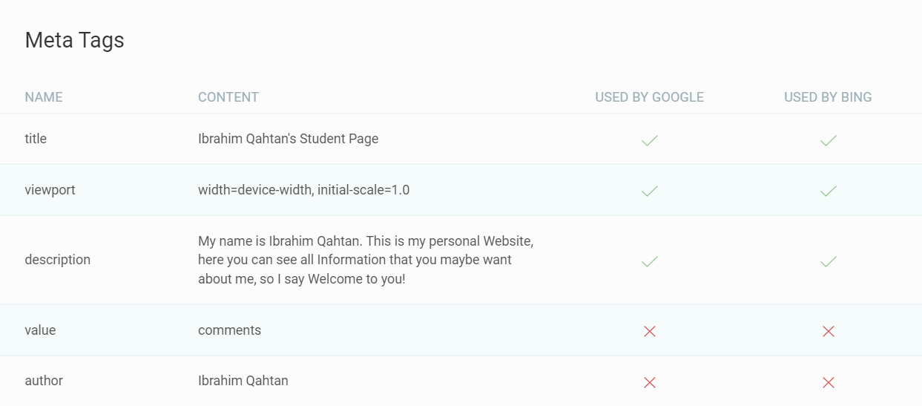

Code
Html Code:
<!DOCTYPE html>
<html lang="en">
<head>
<meta charset="UTF-8" />
<meta name="viewport" content="width=device-width, initial-scale=1.0" />
<meta
name="description"
content="My name is Ibrahim Qahtan. This is my personal Website, here you can see all Information that you maybe want about me, so I say Welcome to you!"
/>
<meta name="value" content="comments" />
<meta name="author" content="Ibrahim Qahtan" />
<title>Ibrahim Qahtan's Student Page</title>
<link rel="stylesheet" href="style1.css" />
</head>
<body>
<header>
<h1>Welcome to Ibrahim Qahtan's Page</h1>
</header>

<div class="main-content">
<div class="profile-section">
<img
src="ibo98x.jpg"
alt="Profile Picture of Ibrahim Qahtan"
class="profile-picture"
/>
<section class="about-me">
<h2>About Me</h2>
<p>
My name is Ibrahim Qahtan, and I am a third-year Computer Science
student at the University of Sulaimani.
</p>
</section>
</div>

<section class="experience">
<h2>My Activities & Experience</h2>
<ul>
<li>Programming in various languages</li>
<li>Content creation for social media</li>
<li>Gaming and streaming online</li>
</ul>
<h3>Programming Languages I Know:</h3>
<ol>
<li>Python</li>
<li>JavaScript</li>
<li>Java</li>
<li>HTMl</li>
<li>CSS</li>
</ol>
</section>

<section class="contact">
<h2>Contact Me</h2>
<p>
If you wish to get in touch, feel free to send me an email at:
<a href="mailto:ibo98x.ads@gamil.com">ibo98x.ads@gamil.com</a>
</p>
</section>

<div class="social-media">
<h2>Find Me on Social Media</h2>
<table>
<thead>
<tr>
<th>Platform</th>
<th>Link</th>
</tr>
</thead>
<tbody>
<tr>
<td>Instagram</td>
<td>
<a href="https://www.instagram.com/ibo98x/" target="_blank">
Instagram Profile
</a>
</td>
</tr>
<tr>
<td>Facebook</td>
<td>
<a
href="https://www.facebook.com/profile.php?id=100083830077593"
target="_blank"
>
Facebook Profile
</a>
</td>
</tr>
</tbody>
</table>
</div>
</div>

<footer>
<p>© 2024 My Personal Page - All Rights Reserved to IBO98X</p>
</footer>
</body>
</html>

Css Code:
body {
font-family: Arial, sans-serif;
margin: 0;
padding: 0;
background-color: #f9f9f9;
color: #333;
}

header {
background-color: #ee4444;
color: white;
text-align: center;
padding: 20px 0;
font-size: 24px;
}

.main-content {
max-width: 800px;
margin: 20px auto;
padding: 15px;
background-color: #ffffff;
border: 1px solid #ddd;
border-radius: 8px;
}

.profile-section {
display: flex;
align-items: center;
gap: 15px;
margin-bottom: 20px;
}

.profile-picture {
width: 120px;
height: 120px;
border-radius: 50%;
object-fit: cover;
}

h2 {
color: #3498db;
font-size: 20px;
margin-bottom: 10px;
}

ul,
ol {
margin: 10px 0;
padding-left: 20px;
}

ul {
list-style-type: square;
}

ol {
list-style-type: decimal;
}

table {
width: 100%;
border-collapse: collapse;
margin-top: 15px;
}

th,
td {
padding: 10px;
border: 1px solid #ccc;
text-align: left;
}

th {
background-color: #f1f1f1;
}

footer {
text-align: center;
padding: 10px 0;
background-color: #ee4444;
color: white;
margin-top: 30px;
}

a {
color: #ee4444;
text-decoration: none;
}

a:hover {
text-decoration: underline;
}

